**LAB REPORT**

***Submitted by***

**VIBHOR KUMAR DEWANGAN(RA2011003010969)**

***Under the Guidance of***

**Mrs. Nagadevi S**

**Assistant Professor , Department of Computing Technologies**

***In partial satisfaction of the requirements for the degree of***

## **BACHELOR OF TECHNOLOGY**

**in**

**COMPUTER SCIENCE ENGINEERING**

**in CSE CORE**

**SCHOOL OF COMPUTING**

# **COLLEGE OF ENGINEERING AND TECHNOLOGY**

**SRM INSTITUTE OF SCIENCE AND TECHNOLOGY**

**KATTANKULATHUR - 603203**

**JUNE 2022**

SRM INSTITUTION OF SCIENCE AND TECHNOLOGY

KATTANKULATHUR-603203

**BONAFIDE CERTIFICATE**

Certified that this lab report titled **“SHOPJANGO (E Commerce Website)”** is the bonafide work done by Vibhor Kumar Dewangan (RA2011003010969), who carried out the lab exercises under my supervision. Certified further, that to the best of my knowledge the work reported herein does not form part of any other work.

|  |  |
| --- | --- |
| **SIGNATURE**  Mrs Nagadevi S  **SEPM – Course Faculty**  Assistant Professor  Department of Computing Technologies |  |

**TABLE OF CONTENTS**

|  |  |  |
| --- | --- | --- |
| **CHAPTER NO** | **TITLE** |  |
| **1** | **ABSTRACT** |  |
| **2** | **PROBLEM STATEMENT** |  |
| **3** | **STAKEHOLDERS & PROCESS MODELS** |  |
| **4** | **IDENTIFYING REQUIREMENTS** |  |
| **5** | **PROJECT PLAN & EFFORT** |  |
| **6** | **WORK BREAKDOWN STRUCTURE & RISK ANALYSIS** |  |

|  |  |  |
| --- | --- | --- |
| **7**  **8**  **9**  **10**  **11**  **12**  **13**  **14** | **SYSTEM ARCHITECTURE, USE CASE & CLASS DIAGRAM**  **ENTITY RELATIONSHIP DIAGRAM**  **DATA FLOW DIAGRAM**  **SEQUENCE & COLLABORATION DIAGRAM**  **DEVELOPMENT OF TESTING FRAMEWORK/USER INTERFACE**  **TEST CASES & REPORTING**  **ARCHITECTURE/DESIGN/FRAMEWORK/IMPLE-MENTATION**    **CONCLUSION** |  |
| **15** | **REFERENCES** |  |
| **16** | **APPENDIX (CODE)** |  |

|  |  |  |
| --- | --- | --- |
|  |  |  |

**1.ABSTRACT**

Electronic Commerce is process of doing business through computer networks. A person sitting on his chair in front of a computer can access all the facilities of the Internet to buy or sell the products.

Unlike traditional commerce that is carried out physically with effort of a person to go & get products, ecommerce has made it easier for human to reduce physical work and to save time. E-Commerce which was started in early 1990’s has taken a great leap in the world of computers, but the fact that has hindered the growth of e-commerce is security. Security is the challenge facing e-commerce today & there is still a lot of advancement made in the field of security.

The main advantage of e-commerce over traditional commerce is the user can browse online shops, compare prices and order merchandise sitting at home on their PC.

For increasing the use of e-commerce in developing countries the B2B e-commerce is implemented for improving access to global markets for firms in developing countries. For a developing country advancement in the field of e-commerce is essential. The research strategy shows the importance of the e-commerce in developing countries for business applications.

***2.PROBLEM STATEMENT***

To Frame a project team, analyse and identify a Software project. To create a business

case and Arrive at a Problem Statement for our project SHOPJANGO(Ecommerce Website).



**3.1 STAKEHOLDERS**

Internal stakeholders:

The internal stakeholders include the team members, managers, executives who are all internally

related.

|  |  |  |
| --- | --- | --- |
| PROJECT ROLE | RESPONSIBILITIES | TEAM MEMBERS ASSIGNED TO |
| PROJECT MANAGER | Planning ,Directing , Delegating  work efficiently and resource  management | VIBHOR |
| TECHNICAL LEAD | Programming and coding | SHIVANSH |
| DEVELOPER | Research,designing,implementation of software programs | VIBHOR,SHIVANSH,  SAYAN |
| TESTER | Develop and execute tests | SAYAN |

**3.2PROCESS MODEL**

B2C, also known as “business-to-consumer” – refers to commerce between a business and an individual consumer. While it applies to any type of direct-to-consumer selling, it has come to be associated with online selling, also known as ecommerce.

In online business-to-consumer sales, there are generally five business models:

### **1. Direct Sellers**

This is the type of B2C most people are familiar with – they are the online retail sites where consumers buy products. They can be manufacturers such as Gap or Dell or small businesses that create and sell products, but they can also be online versions of department stores selling products from a wide range of brands and manufacturers. Examples include Target.com, Macys.com, and Zappos.com.

### **2. Online Intermediaries**

These “go-betweens” put buyers and sellers together without owning the product or service. Examples include online travel sites such as Expedia and Trivago and arts and crafts retailer Etsy.

### **3. Advertising-Based**

This B2C approach leverages high volumes of web traffic to sell advertising which, in turn, sells products or services to the consumer. This model uses high-quality free content to attract site visitors, who then encounter online ads. Media outlets that have no paid subscription component, such as the Huffington Post and Observer.com, are examples.

### **4. Community-Based**

This B2C model uses online communities built around shared interests to help advertisers market their products directly to site users. It could be an online forum for photography buffs, people with diabetes, or marching band members. The best-known example is Facebook, which helps marketers target ads to people according to very specific demographics.

### **5. Fee-Based**

These direct-to-consumer sites charge a subscription fee for access to their content. They typically include publications that offer a limited amount of content for free but charge for most of it – such as The Wall Street Journal – or entertainment services such as Netflix or Hulu.

Businesses selling directly to consumers should take into account how their target customers like to shop and buy products like theirs as they explore various business-to-consumer options, whether those possibilities involve in-person or online transactions.

**4. IDENTIFYING REQUIREMENTS**

**User Requirements**

• able to view the status of items they have ordered.

• able to select items of interest and add them to their shopping carts for future purchase.

• able to view a complete list of specified items available through the site.

• able to search for items by related attributes.

• The performance of the application should not degrade with an increase in the number of

goods or services offered.

**System Requirements**

• Windows 8+ or higher OS versions

• Any latest web browser. HTML, CSS and Java Script for user interface

• For server , ISS 7 or greater with .NET Framework 4 or above

• A portable service to host and Visual Studio as an IDE

**Functional Requirements**

• Speed

• Mobile-friendliness

• Ease of use in the checkout flow

• Personalization

• Accessibility

**Non-Functional Requirements**

• Usability

• Security

• Performance

• Scalability

• Maintainability

**5. PROJECT MANAGEMENT PLAN**

|  |  |
| --- | --- |
| FOCUS AREA | DETAILS |
| Integration Management | Project Team Structure  Roles &amp; Responsibilities of Team  Project Closure |
| Scope Management | Scope Statement  Requirement Management (Gathering, Control, Assumption, Constraint Stakeholder)  Define Deliverable  Activities and Sub-Tasks |
| Schedule Management | Define Milestones  Schedule Control |
| Resource Management | Estimate and Manage the need  People: People &amp; Skills Required  Physical: Facilities |
| Communication Management | Determine communication requirements, roles and responsibilities, tools and techniques. |

**6.1 WORK BREAKDOWN STRUCTURE**

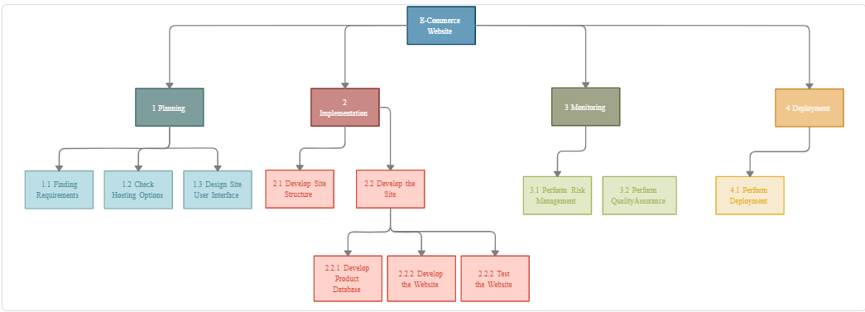

**** 0.0 Ecommerce Web Site

 1.0 Planning

 2.0 Implementation

◦ 2.1 Develop Site Structure

◦ 2.2 Develop the Site

 2.2.1 Develop Product Database

 2.2.2 Develop the Website

 2.2.3 Test the Website

 3.0 Monitoring

◦ 3.1 Perform Risk Management

◦ 3.2 Perform Quality Assurance

◦ 4.0 Development

◦ 4.1 Perform Development

**6.2RISK ANALYSIS**

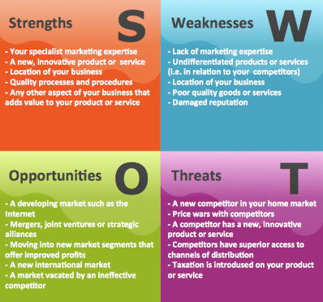

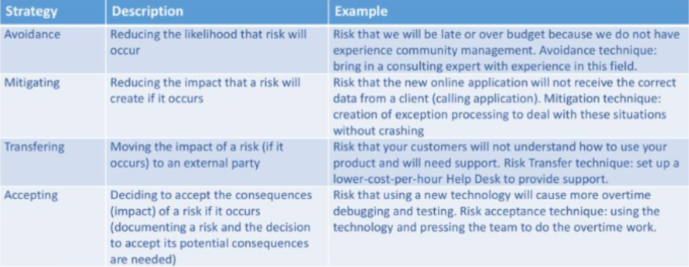

**7.1SYSTEM ARCHITECTURE**

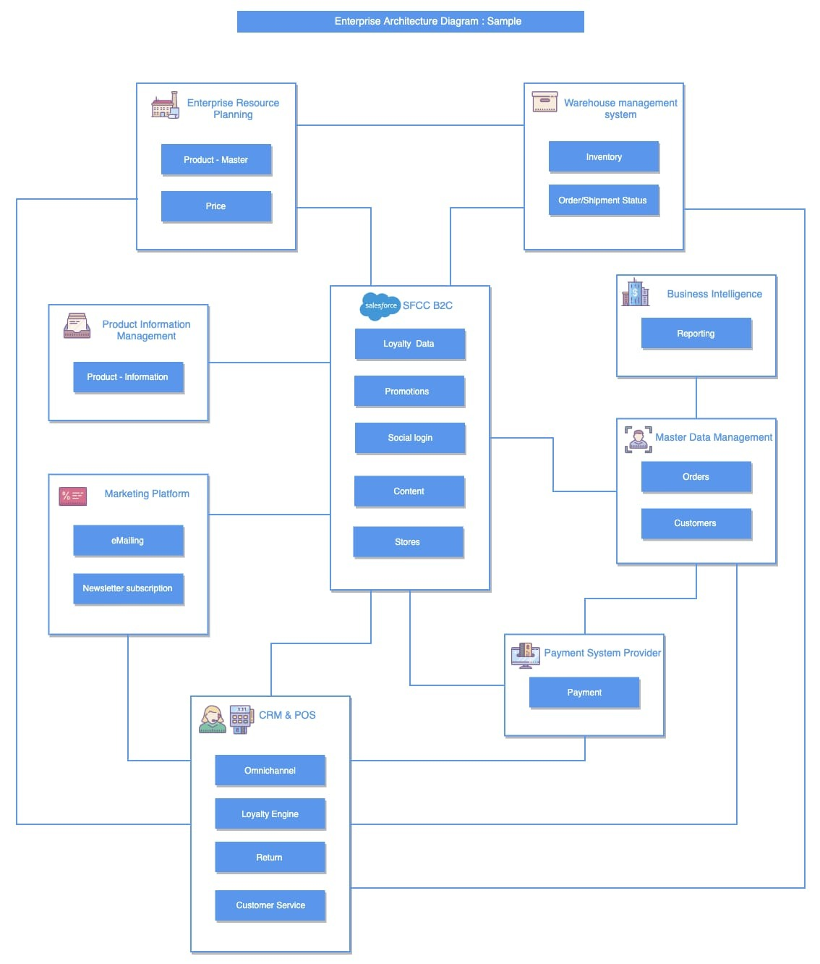

**7.2 USE CASE DIAGRAM**

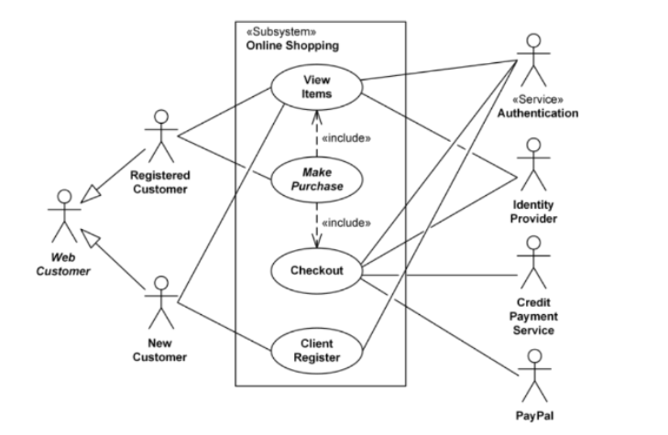

**7.3 CLASS DIAGRAM**

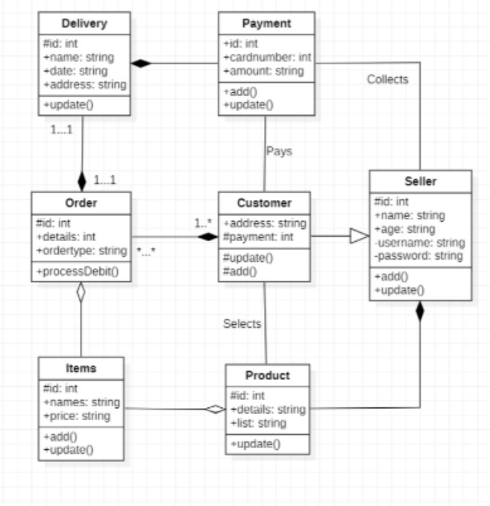

**8. ENTITY RELATIONSHIP DIAGRAM**

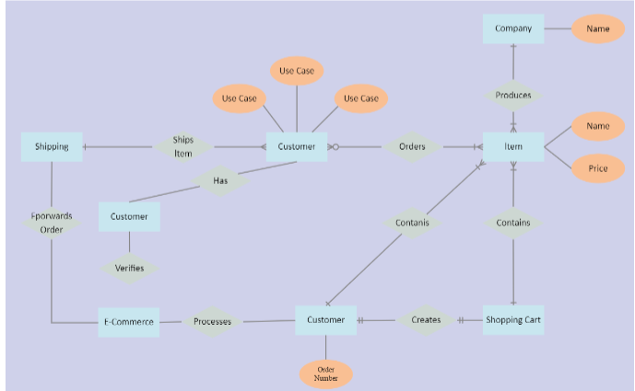

**9. DATAFLOW DIAGRAM**

**DF Level 0**

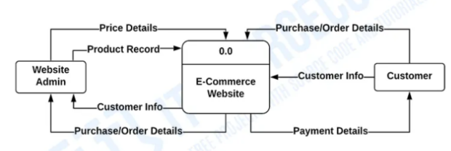

**DF Level 1**

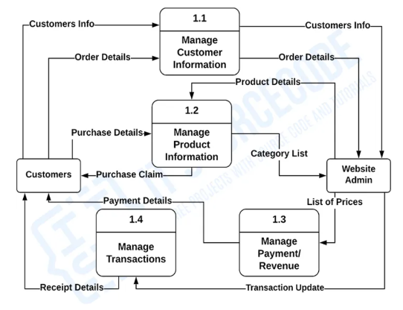

**10.1 SEQUENCE DIAGRAM**

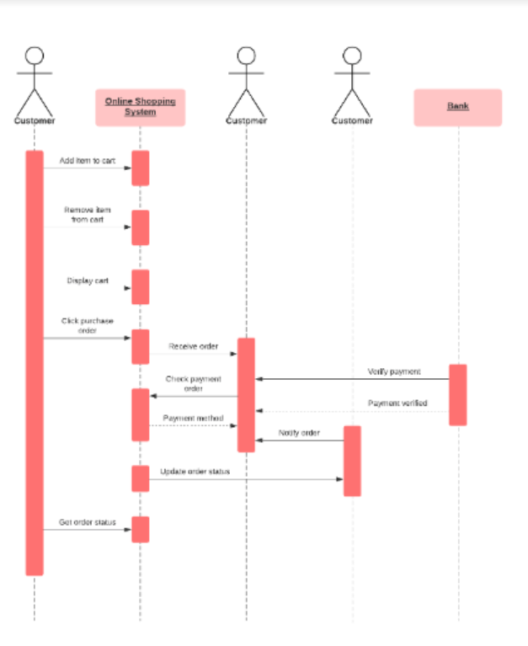

**10.2 COLLABORATION DIAGRAM**

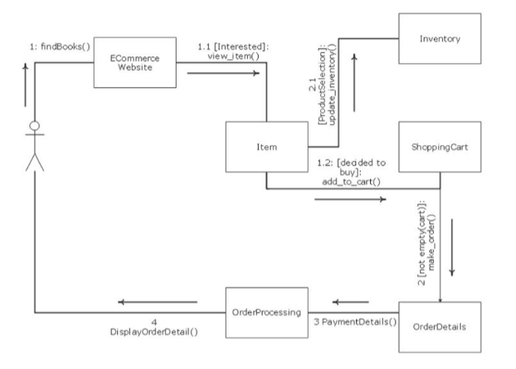

**11. DEVELOPMENT OF TESTING AND FRAMEWORK**

**To design effective test cases for identifying the errors**

* Finding errors or defects which may be created while developing News Portal
* To check whether all the news is correct or not
* To be confident about the quality of the product

**Functional Requirement Testing**:

* Check whether product is adding on cart
* User feedback
* Correct Product with detailing

**Non-Functional Requirement :**

* Check whether Font and size of the website is correct or not
* Check whether website is working properly or not
* Check whether website is slow or not
* Check whether any vulnerability

|  |  |  |
| --- | --- | --- |
| Category | Methodology | Tools Required |
| Functional  Requirements | Manual | Word Template, Feedback,  Fast experience |
| Non-Functional | Manual | Word Template ,Design ,Security |

**12. TEST CASES AND REPORTING**

|  |  |  |  |  |  |  |
| --- | --- | --- | --- | --- | --- | --- |
| **Test ID (#)** | **Test Scenario** | **Test Case** | **Expected Outcome** | **Actual Outcome** | **Status** | **Remarks** |
|  | 1  2 | Verify if a user cannot enter the characters more than the specified range in each field (Username and Password).  Verify the timeout functionality of the login session | Negative  Positive | Negative  Positive | Pass  Pass | Improvement needs to be done  nil |

|  |  |  |  |  |  |  |  |
| --- | --- | --- | --- | --- | --- | --- | --- |
| **Test ID (#)** | **Test Scenario** | **Test Case** | **Execution Steps** | **Expected Outcome** | **Actual Outcome** | **Status** | **Remarks** |
|  | Add-to-Cart/Add-to-Wishlist Functionality | Add-to-Cart | 1.Add all the products you wish to buy in the cart | User should be able to add products in cart | User is able to add products in cart | Pass | Success |

|  |  |  |  |  |  |  |  |
| --- | --- | --- | --- | --- | --- | --- | --- |
| **Test ID (#)** | **Test Scenario** | **Test Case** | **Execution Steps** | **Expected Outcome** | **Actual Outcome** | **Status** | **Remarks** |
|  | Accessibility | The user should be able to navigate through the website properly and easily | Design a beautiful user Interface and give high attention to details | Positive | Positive | Pass | Success |

|  |  |  |
| --- | --- | --- |
| **Category** | **Progress Against Plan** | **Status** |
| Functional Testing | Green | Completed |
| Non-Functional Testing | green | Completed |

|  |  |  |
| --- | --- | --- |
| **Functional** | **Test Case Coverage (%)** | **Status** |
| Add to cart | 100% | Complete |
| **NON Functional** | **Test Case Coverage (%)** | **Status** |
| Accessibility | 100% | Completed |

**13. ARCHITECTURE/DESIGN/FRAMEWORK/IMPLEMENTATION**

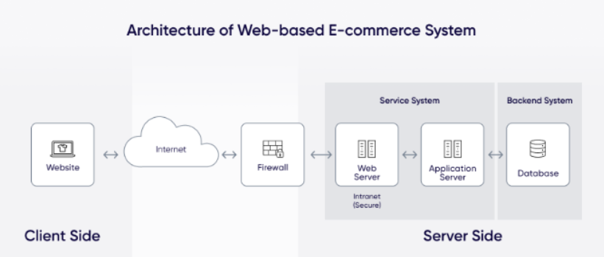

* **HOME PAGE**

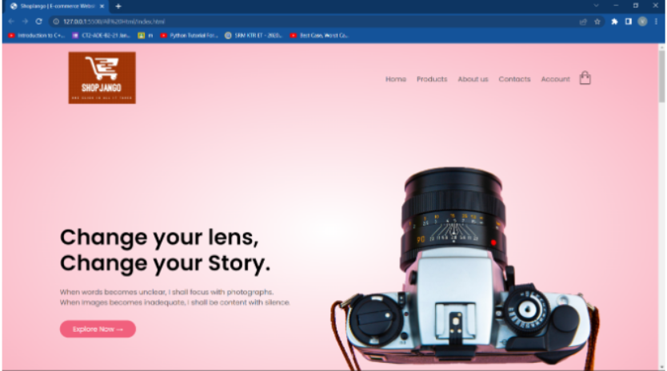

* **PRODUCT PAGE**

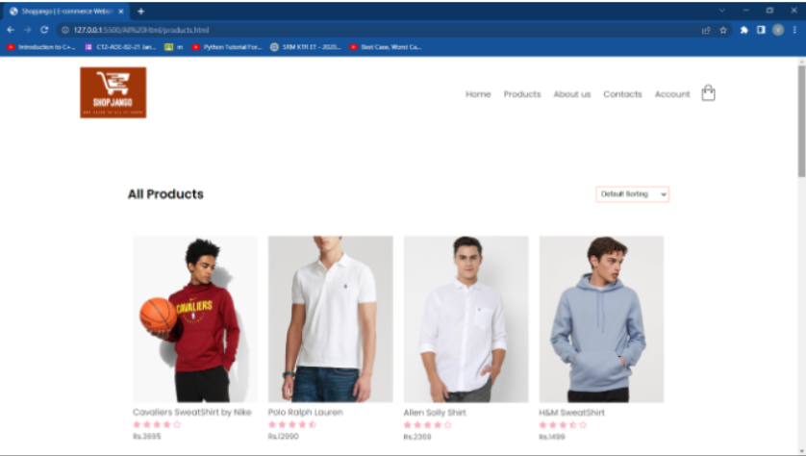

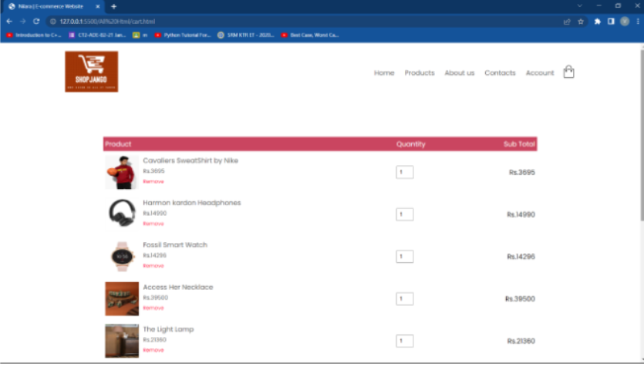

**14. CONCLUSION**

E-commerce still represents one of the business methods that take advantage if done the right way, even if the stock market and commodities fell, but E-Commerce still able to survive and receive high transaction. E-commerce has a tremendous opportunity in the course of or business all over the world. In addition, it is also to introducing new techniques and styles in a transaction.

It has undeniably become an important part of our society. The successful companies of the future will be those that take E-Commerce seriously, dedicating sufficient resources to its development. Companies that use it as a reason for completely re-designing their business processes are likely to reap the greatest benefits. Moreover, E-Commerce is a helpful technology that gives the consumer access to business and companies all over the world

**15. REFERENCES**

1. <https://www.zoho.com/commerce/?utm_source=adwords&utm_medium=cpc&utm_campaign=EM-ecommerce-platform>
2. <https://www.bigcommerce.com/articles/ecommerce/best-ecommerce-website-design>
3. <https://www.wix.com/ecommerce/website>

**16.APPENDIX-CODES**

//**index page code**

<!DOCTYPE html>

<html lang="en">

<head>

<meta charset="UTF-8" />

<meta name="viewport" content="width=device-width, initial-scale=1.0" />

<link rel="stylesheet" href="style.css" />

<title>ShopJango | E-commerce Website</title>

<link href="https://fonts.googleapis.com/css2?family=Poppins:wght@300;400;500;600&display=swap" rel="stylesheet" />

<link rel="stylesheet" href="https://stackpath.bootstrapcdn.com/font-awesome/4.7.0/css/font-awesome.min.css" />

</head>

<body>

<div class="header">

<div class="container">

<div class="navbar">

<div class="logo">

<a href="index.html">

<img src="images/main-logo.png" alt="" / width="155px">

</a>

</div>

<nav>

<ul id="MenuItems">

<li><a href="index.html">Home</a></li>

<li><a href="products.html">Products</a></li>

<li><a href="">About us</a></li>

<li><a href="">Contacts</a></li>

<li><a href="account.html">Account</a></li>

</ul>

</nav>

<a href="cart.html">

<img src="images/cart.png" alt="" width="30px" height="30px" />

</a>

<img src="images/menu.png" alt="" class="menu-icon" onclick="menutoggle()">

</div>

<div class="row">

<div class="col-2">

<h1>Change your lens, <br />Change your Story.</h1>

<p>

When words becomes unclear, I shall focus with photographs.<br />When

Images becomes inadequate, I shall be content with silence.

</p>

<a href="" class="btn">Explore Now &#8594;</a>

</div>

<div class="col-2">

<img src="images/main.png" alt="" />

</div>

</div>

</div>

</div>

<div class="categories">

<div class="small-container">

<div class="row">

<div class="col-3">

<img src="images/category1.png" alt="" />

</div>

<div class="col-3">

<img src="images/category2.png" alt="" />

</div>

<div class="col-3">

<img src="images/category3.png" alt="" />

</div>

</div>

</div>

</div>

<div class="small-container">

<h2 class="title">Featured Products</h2>

<div class="row">

<div class="col-4">

<a href="product-details.html">

<img src="images/pro1-nike-3695.png" alt="" />

</a>

<a href="product-details.html">

<h4>Cavaliers SweatShirt by Nike</h4>

</a>

<div class="rating">

<i class="fa fa-star"></i>

<i class="fa fa-star"></i>

<i class="fa fa-star"></i>

<i class="fa fa-star"></i>

<i class="fa fa-star-o"></i>

</div>

<p>Rs.3695</p>

</div>

<div class="col-4">

<img src="images/pro2-Polo Ralph Lauren-12990.png" alt="" />

<h4>Polo Ralph Lauren</h4>

<div class="rating">

<i class="fa fa-star"></i>

<i class="fa fa-star"></i>

<i class="fa fa-star"></i>

<i class="fa fa-star"></i>

<i class="fa fa-star-half-o"></i>

</div>

<p>Rs.12990</p>

</div>

<div class="col-4">

<img src="images/pro3-allen solly - 2369.png" alt="" />

<h4>Allen Solly Shirt</h4>

<div class="rating">

<i class="fa fa-star"></i>

<i class="fa fa-star"></i>

<i class="fa fa-star"></i>

<i class="fa fa-star"></i>

<i class="fa fa-star-o"></i>

</div>

<p>Rs.2369</p>

</div>

<div class="col-4">

<img src="images/pro4-h&m-1499.png" alt="" />

<h4>H&M SweatShirt</h4>

<div class="rating">

<i class="fa fa-star"></i>

<i class="fa fa-star"></i>

<i class="fa fa-star"></i>

<i class="fa fa-star-half-o"></i>

<i class="fa fa-star-o"></i>

</div>

<p>Rs.1499</p>

</div>

</div>

<h2 class="title">Latest Products</h2>

<div class="row">

<div class="col-4">

<img src="images/pro5-calvinK-4199.png" alt="" />

<h4>Calvin Klein Sweater</h4>

<div class="rating">

<i class="fa fa-star"></i>

<i class="fa fa-star"></i>

<i class="fa fa-star"></i>

<i class="fa fa-star"></i>

<i class="fa fa-star-o"></i>

</div>

<p>Rs.4199</p>

</div>

<div class="col-4">

<img src="images/pro6-SELECTED-11499.png" alt="" />

<h4>SELECTED Blazer</h4>

<div class="rating">

<i class="fa fa-star"></i>

<i class="fa fa-star"></i>

<i class="fa fa-star"></i>

<i class="fa fa-star"></i>

<i class="fa fa-star-half-o"></i>

</div>

<p>Rs.11499</p>

</div>

<div class="col-4">

<img src="images/pro7-anubhutte-988.png" alt="" />

<h4>Anubhutte Dress</h4>

<div class="rating">

<i class="fa fa-star"></i>

<i class="fa fa-star"></i>

<i class="fa fa-star"></i>

<i class="fa fa-star"></i>

<i class="fa fa-star-o"></i>

</div>

<p>Rs.988</p>

</div>

<div class="col-4">

<img src="images/pro8-biba-3039.png" alt="" />

<h4>Biba Dress</h4>

<div class="rating">

<i class="fa fa-star"></i>

<i class="fa fa-star"></i>

<i class="fa fa-star"></i>

<i class="fa fa-star-half-o"></i>

<i class="fa fa-star-o"></i>

</div>

<p>Rs.3039</p>

</div>

</div>

<div class="row">

<div class="col-4">

<img src="images/pro9-dorothy perkins-1245.png" alt="" />

<h4>Dorothy Perkins Skirt</h4>

<div class="rating">

<i class="fa fa-star"></i>

<i class="fa fa-star"></i>

<i class="fa fa-star"></i>

<i class="fa fa-star"></i>

<i class="fa fa-star-o"></i>

</div>

<p>Rs.1245</p>

</div>

<div class="col-4">

<img src="images/pro10-bobbi brown-5600.png" alt="" />

<h4>Bobbi Brown Cream</h4>

<div class="rating">

<i class="fa fa-star"></i>

<i class="fa fa-star"></i>

<i class="fa fa-star"></i>

<i class="fa fa-star"></i>

<i class="fa fa-star-half-o"></i>

</div>

<p>Rs.5600</p>

</div>

<div class="col-4">

<img src="images/pro11-AccessHer-39500.png" alt="" />

<h4>Access Her necklace</h4>

<div class="rating">

<i class="fa fa-star"></i>

<i class="fa fa-star"></i>

<i class="fa fa-star"></i>

<i class="fa fa-star"></i>

<i class="fa fa-star-o"></i>

</div>

<p>Rs.39500</p>

</div>

<div class="col-4">

<img src="images/pro12-fossil-14296.png" alt="" />

<h4>Fossil Smart Watch</h4>

<div class="rating">

<i class="fa fa-star"></i>

<i class="fa fa-star"></i>

<i class="fa fa-star"></i>

<i class="fa fa-star-half-o"></i>

<i class="fa fa-star-o"></i>

</div>

<p>Rs.14296</p>

</div>

</div>

</div>

<div class="offer">

<div class="small-container">

<div class="row">

<div class="col-2">

<img src="images/offer/shopping.png" alt="" class="offer-img" />

</div>

<div class="col-2">

<p>Exclusively Available on ShopJango</p>

<h1>Apple watch series 5</h1>

<small>

With a new Always-On Retina display, Apple Watch Series 5 is

always there for you. To monitor your health, help you stay fit

and keep you connected.

</small>

<a href="#" class="btn">Buy Now &#8594;</a>

</div>

</div>

</div>

</div>

<div class="testimonial">

<div class="small-container">

<div class="row">

<div class="col-3">

<i class="fa fa-quote-left"></i>

<p>

i bought a smartwatch from shopjango.Excellent finish and smooth touch. The screen clarity n sensor

touch is good. A light scroll is good enough to move around the

features. Light weight and smart look. Just what I wanted.

</p>

<div class="rating">

<i class="fa fa-star"></i>

<i class="fa fa-star"></i>

<i class="fa fa-star"></i>

<i class="fa fa-star"></i>

<i class="fa fa-star-half-o"></i>

</div>

<img src="images/user-1.jpg" alt="">

<h3>Nilay Hirpara</h3>

</div>

<div class="col-3">

<i class="fa fa-quote-left"></i>

<p>

Merchandise at its level best

</p>

<div class="rating">

<i class="fa fa-star"></i>

<i class="fa fa-star"></i>

<i class="fa fa-star"></i>

<i class="fa fa-star"></i>

<i class="fa fa-star-half-o"></i>

</div>

<img src="images/user-2.jpg" alt="">

<h3>Ananya Kashyap</h3>

</div>

<div class="col-3">

<i class="fa fa-quote-left"></i>

<p>

The products are of high quality .I enjoy the wide range of variety.

</p>

<div class="rating">

<i class="fa fa-star"></i>

<i class="fa fa-star"></i>

<i class="fa fa-star"></i>

<i class="fa fa-star"></i>

<i class="fa fa-star-half-o"></i>

</div>

<img src="images/user-3.jpg" alt="">

<h3>Navnit Kumar</h3>

</div>

</div>

</div>

</div>

<div class="brands">

<div class="small-container">

<div class="row">

<div class="col-5">

<img src="images/logo-1.png" alt="">

</div>

<div class="col-5">

<img src="images/logo-2.png" alt="">

</div>

<div class="col-5">

<img src="images/logo-3.png" alt="">

</div>

<div class="col-5">

<img src="images/logo-4.png" alt="">

</div>

<div class="col-5">

<img src="images/logo-5.png" alt="">

</div>

</div>

</div>

</div>

<div class="footer">

<div class="container">

<div class="row">

<div class="footer-col-1">

<h3>Download our App</h3>

<p>Download App for Andriod and ios mobile phone.</p>

<div class="app-logo">

<img src="images/play-store.png" alt="">

<img src="images/app-store.png" alt="">

</div>

</div>

<div class="footer-col-2">

<img src="images/main-logo.png" alt="" / width="30" px>

<p>Our purpose is to give the best quality product to the customer and bring them back and make them

happy.</p>

</div>

<div class="footer-col-3">

<h3>Useful Links</h3>

<ul>

<li>Coupons</li>

<li>Blog Post</li>

<li>Return Policy</li>

<li>Join Affiliate</li>

</ul>

</div>

<div class="footer-col-4">

<h3>Follow Us</h3>

<ul>

<li>Facebook</li>

<li>Twitter</li>

<li>Instagram</li>

<li>Youtube</li>

</ul>

</div>

</div>

<hr>

<p class="copyright">Copyright &copy; 2022 - www.shopjango.com</p>

</div>

</div>

<script>

var MenuItems = document.getElementById("MenuItems");

MenuItems.style.maxHeight = "0px";

function menutoggle() {

if (MenuItems.style.maxHeight == "0px") {

MenuItems.style.maxHeight = "200px";

}

else {

MenuItems.style.maxHeight = "0px";

}

}

</script>

</body>

</html>

**//product details**

<!DOCTYPE html>

<html lang="en">

<head>

<meta charset="UTF-8" />

<meta name="viewport" content="width=device-width, initial-scale=1.0" />

<link rel="stylesheet" href="style.css" />

<title>Nilara | E-commerce Website</title>

<link href="https://fonts.googleapis.com/css2?family=Poppins:wght@300;400;500;600&display=swap" rel="stylesheet" />

<link rel="stylesheet" href="https://stackpath.bootstrapcdn.com/font-awesome/4.7.0/css/font-awesome.min.css" />

</head>

<body>

<div class="container">

<div class="navbar">

<div class="logo">

<a href="index.html">

<img src="images/main-logo.png" alt="" / width="125px">

</a>

</div>

<nav>

<ul id="MenuItems">

<li><a href="index.html">Home</a></li>

<li><a href="products.html">Products</a></li>

<li><a href="">About us</a></li>

<li><a href="">Contacts</a></li>

<li><a href="account.html">Account</a></li>

</ul>

</nav>

<a href="cart.html">

<img src="images/cart.png" alt="" width="30px" height="30px" />

</a>

<img src="images/menu.png" alt="" class="menu-icon" onclick="menutoggle()">

</div>

</div>

<div class="small-container single-product">

<div class="row">

<div class="col-2">

<img src="images/gal1.png" alt="" width="100%" id="ProductImg">

<div class="small-img-row">

<div class="small-img-col">

<img src="images/gal1.png" alt="" width="100%" class="small-img">

</div>

<div class="small-img-col">

<img src="images/gal2.png" alt="" width="100%" class="small-img">

</div>

<div class="small-img-col">

<img src="images/gal3.png" alt="" width="100%" class="small-img">

</div>

<div class="small-img-col">

<img src="images/gal4.png" alt="" width="100%" class="small-img">

</div>

</div>

</div>

<div class="col-2">

<p>Home / SweatShirt</p>

<h1>Cavaliers SweatShirt by Nike</h1>

<h4>Rs.3695</h4>

<select>

<option>Select Size</option>

<option>XXL</option>

<option>XL</option>

<option>L</option>

<option>M</option>

<option>S</option>

</select>

<input type="number" value="1">

<a href="" class="btn">Add to Cart</a>

<h3>Product Details <i class="fa fa-indent"></i></h3>

<br>

<p>Cleveland Cavaliers Nike Spotlight Men's NBA Hoodie PLAY WITH PRIDE. Cleveland Cavaliers Nike

Spotlight Men's NBA Hoodie keeps you feeling comfortable and agile on the practice court. Inspired

by the authentic, on-court NBA warm-up, this pullover is made from durable knit fabric that's

powered by sweat-wicking Dri-FIT technology.</p>

</div>

</div>

</div>

<div class="small-container">

<div class="row row-2">

<h2>Related Products</h2>

<p>View More</p>

</div>

</div>

<div class="small-container">

<div class="row">

<div class="col-4">

<img src="images/pro1-nike-3695.png" alt="" />

<h4>Cavaliers SweatShirt by Nike</h4>

<div class="rating">

<i class="fa fa-star"></i>

<i class="fa fa-star"></i>

<i class="fa fa-star"></i>

<i class="fa fa-star"></i>

<i class="fa fa-star-o"></i>

</div>

<p>Rs.3695</p>

</div>

<div class="col-4">

<img src="images/pro2-Polo Ralph Lauren-12990.png" alt="" />

<h4>Polo Ralph Lauren</h4>

<div class="rating">

<i class="fa fa-star"></i>

<i class="fa fa-star"></i>

<i class="fa fa-star"></i>

<i class="fa fa-star"></i>

<i class="fa fa-star-half-o"></i>

</div>

<p>Rs.12990</p>

</div>

<div class="col-4">

<img src="images/pro3-allen solly - 2369.png" alt="" />

<h4>Allen Solly Shirt</h4>

<div class="rating">

<i class="fa fa-star"></i>

<i class="fa fa-star"></i>

<i class="fa fa-star"></i>

<i class="fa fa-star"></i>

<i class="fa fa-star-o"></i>

</div>

<p>Rs.2369</p>

</div>

<div class="col-4">

<img src="images/pro4-h&m-1499.png" alt="" />

<h4>H&M SweatShirt</h4>

<div class="rating">

<i class="fa fa-star"></i>

<i class="fa fa-star"></i>

<i class="fa fa-star"></i>

<i class="fa fa-star-half-o"></i>

<i class="fa fa-star-o"></i>

</div>

<p>Rs.1499</p>

</div>

</div>

</div>

</div>

<div class="footer">

<div class="container">

<div class="row">

<div class="footer-col-1">

<h3>Download our App</h3>

<p>Download App for Andriod and ios mobile phone.</p>

<div class="app-logo">

<img src="images/play-store.png" alt="">

<img src="images/app-store.png" alt="">

</div>

</div>

<div class="footer-col-2">

<img src="images/main-logo.png" alt="">

<p>Our purpose is to give the best quality product to the customer and bring them back and make them

happy.</p>

</div>

<div class="footer-col-3">

<h3>Useful Links</h3>

<ul>

<li>Coupons</li>

<li>Blog Post</li>

<li>Return Policy</li>

<li>Join Affiliate</li>

</ul>

</div>

<div class="footer-col-4">

<h3>Follow Us</h3>

<ul>

<li>Facebook</li>

<li>Twitter</li>

<li>Instagram</li>

<li>Youtube</li>

</ul>

</div>

</div>

<hr>

<p class="copyright">Copyright &copy; 2020 - www.nilara.com</p>

</div>

</div>

<script>

var MenuItems = document.getElementById("MenuItems");

MenuItems.style.maxHeight = "0px";

function menutoggle() {

if (MenuItems.style.maxHeight == "0px") {

MenuItems.style.maxHeight = "200px";

}

else {

MenuItems.style.maxHeight = "0px";

}

}

</script>

<script>

var ProductImg = document.getElementById("ProductImg");

var SmallImg = document.getElementsByClassName("small-img");

SmallImg[0].onclick = function () {

ProductImg.src = SmallImg[0].src;

}

SmallImg[1].onclick = function () {

ProductImg.src = SmallImg[1].src;

}

SmallImg[2].onclick = function () {

ProductImg.src = SmallImg[2].src;

}

SmallImg[3].onclick = function () {

ProductImg.src = SmallImg[3].src;

}

</script>

</body>

</html>

**//CART**

<!DOCTYPE html>

<html lang="en">

<head>

<meta charset="UTF-8" />

<meta name="viewport" content="width=device-width, initial-scale=1.0" />

<link rel="stylesheet" href="style.css" />

<title>Nilara | E-commerce Website</title>

<link href="https://fonts.googleapis.com/css2?family=Poppins:wght@300;400;500;600&display=swap" rel="stylesheet" />

<link rel="stylesheet" href="https://stackpath.bootstrapcdn.com/font-awesome/4.7.0/css/font-awesome.min.css" />

</head>

<body>

<div class="container">

<div class="navbar">

<div class="logo">

<a href="index.html">

<img src="images/main-logo.png" alt="" / width="125px">

</a>

</div>

<nav>

<ul id="MenuItems">

<li><a href="index.html">Home</a></li>

<li><a href="products.html">Products</a></li>

<li><a href="">About us</a></li>

<li><a href="">Contacts</a></li>

<li><a href="account.html">Account</a></li>

</ul>

</nav>

<a href="cart.html">

<img src="images/cart.png" alt="" width="30px" height="30px" />

</a>

<img src="images/menu.png" alt="" class="menu-icon" onclick="menutoggle()">

</div>

</div>

</div>

<div class="small-container cart-page">

<table>

<tr>

<th>Product</th>

<th>Quantity</th>

<th>Sub Total</th>

</tr>

<tr>

<td>

<div class="cart-info">

<img src="images/buy-1.png" alt="">

<div>

<p>Cavaliers SweatShirt by Nike</p>

<small>Rs.3695</small>

<br>

<a href="">Remove</a>

</div>

</div>

</td>

<td> <input type="number" value="1"></td>

<td>Rs.3695</td>

</tr>

<tr>

<td>

<div class="cart-info">

<img src="images/pro15-harmon kardon-14990.png" alt="">

<div>

<p>Harmon kardon Headphones</p>

<small>Rs.14990</small>

<br>

<a href="">Remove</a>

</div>

</div>

</td>

<td> <input type="number" value="1"></td>

<td>Rs.14990</td>

</tr>

<tr>

<td>

<div class="cart-info">

<img src="images/pro12-fossil-14296.png" alt="">

<div>

<p>Fossil Smart Watch</p>

<small>Rs.14296</small>

<br>

<a href="">Remove</a>

</div>

</div>

</td>

<td> <input type="number" value="1"></td>

<td>Rs.14296</td>

</tr>

<tr>

<td>

<div class="cart-info">

<img src="images/pro11-AccessHer-39500.png" alt="">

<div>

<p>Access Her Necklace</p>

<small>Rs.39500</small>

<br>

<a href="">Remove</a>

</div>

</div>

</td>

<td> <input type="number" value="1"></td>

<td>Rs.39500</td>

</tr>

<tr>

<td>

<div class="cart-info">

<img src="images/pro14-The Light Lamp-21360.png" alt="">

<div>

<p>The Light Lamp</p>

<small>Rs.21360</small>

<br>

<a href="">Remove</a>

</div>

</div>

</td>

<td> <input type="number" value="1"></td>

<td>Rs.21360</td>

</tr>

<tr>

<td>

<div class="cart-info">

<img src="images/pro16-steve madden - 8999.png" alt="">

<div>

<p>Steve Madden Heels</p>

<small>Rs.8999</small>

<br>

<a href="">Remove</a>

</div>

</div>

</td>

<td> <input type="number" value="1"></td>

<td>Rs.8999</td>

</tr>

</table>

<div class="total-price">

<table>

<tr>

<td>Sub Total</td>

<td>Rs.102840</td>

</tr>

<tr>

<td>Tax</td>

<td>Rs.5713.34</td>

</tr>

<tr>

<td>Grand Total</td>

<td>Rs.108553.34</td>

</tr>

</table>

</div>

</div>

<div class="footer">

<div class="container">

<div class="row">

<div class="footer-col-1">

<h3>Download our App</h3>

<p>Download App for Andriod and ios mobile phone.</p>

<div class="app-logo">

<img src="images/play-store.png" alt="">

<img src="images/app-store.png" alt="">

</div>

</div>

<div class="footer-col-2">

<img src="images/main-logo.png" alt="">

<p>Our purpose is to give the best quality product to the customer and bring them back and make them

happy.</p>

</div>

<div class="footer-col-3">

<h3>Useful Links</h3>

<ul>

<li>Coupons</li>

<li>Blog Post</li>

<li>Return Policy</li>

<li>Join Affiliate</li>

</ul>

</div>

<div class="footer-col-4">

<h3>Follow Us</h3>

<ul>

<li>Facebook</li>

<li>Twitter</li>

<li>Instagram</li>

<li>Youtube</li>

</ul>

</div>

</div>

<hr>

<p class="copyright">Copyright &copy; 2020 - www.nilara.com</p>

</div>

</div>

<script>

var MenuItems = document.getElementById("MenuItems");

MenuItems.style.maxHeight = "0px";

function menutoggle() {

if (MenuItems.style.maxHeight == "0px") {

MenuItems.style.maxHeight = "200px";

}

else {

MenuItems.style.maxHeight = "0px";

}

}

</script>

</body>

<!DOCTYPE html>

<html lang="en">

<head>

<meta charset="UTF-8" />

<meta name="viewport" content="width=device-width, initial-scale=1.0" />

<link rel="stylesheet" href="style.css" />

<title>Shopjango | E-commerce Website</title>

<link href="https://fonts.googleapis.com/css2?family=Poppins:wght@300;400;500;600&display=swap" rel="stylesheet" />

<link rel="stylesheet" href="https://stackpath.bootstrapcdn.com/font-awesome/4.7.0/css/font-awesome.min.css" />

</head>

<body>

<div class="container">

<div class="navbar">

<div class="logo">

<a href="index.html">

<img src="images/main-logo.png" alt="" / width="125px">

</a>

</div>

<nav>

<ul id="MenuItems">

<li><a href="index.html">Home</a></li>

<li><a href="products.html">Products</a></li>

<li><a href="">About us</a></li>

<li><a href="">Contacts</a></li>

<li><a href="account.html">Account</a></li>

</ul>

</nav>

<a href="cart.html">

<img src="images/cart.png" alt="" width="30px" height="30px" />

</a>

<img src="images/menu.png" alt="" class="menu-icon" onclick="menutoggle()">

</div>

</div>

</div>

<div class="account-page">

<div class="container">

<div class="row">

<div class="col-2">

<img src="images/main.png" alt="">

</div>

<div class="col-2">

<div class="form-container">

<div class="form-btn">

<span onclick="login()">Login</span>

<span onclick="register()">Sign up</span>

<hr id="Indicator">

</div>

<form id="LoginForm">

<input type="text" placeholder="Username">

<input type="password" placeholder="Password">

<button type="submit" class="btn">Login</button>

<a href="">Forgot Password</a>

</form>

<form id="RegForm">

<input type="text" placeholder="Username">

<input type="email" placeholder="Email">

<input type="password" placeholder="Password">

<button type="submit" class="btn">Sign Up</button>

</form>

</div>

</div>

</div>

</div>

</div>

<div class="footer">

<div class="container">

<div class="row">

<div class="footer-col-1">

<h3>Download our App</h3>

<p>Download App for Andriod and ios mobile phone.</p>

<div class="app-logo">

<img src="images/play-store.png" alt="">

<img src="images/app-store.png" alt="">

</div>

</div>

<div class="footer-col-2">

<img src="images/main-logo.png" alt="">

<p>Our purpose is to give the best quality product to the customer and bring them back and make them

happy.</p>

</div>

<div class="footer-col-3">

<h3>Useful Links</h3>

<ul>

<li>Coupons</li>

<li>Blog Post</li>

<li>Return Policy</li>

<li>Join Affiliate</li>

</ul>

</div>

<div class="footer-col-4">

<h3>Follow Us</h3>

<ul>

<li>Facebook</li>

<li>Twitter</li>

<li>Instagram</li>

<li>Youtube</li>

</ul>

</div>

</div>

<hr>

<p class="copyright">Copyright &copy; 2020 - www.shopjango.com</p>

</div>

</div>

<script>

var MenuItems = document.getElementById("MenuItems");

MenuItems.style.maxHeight = "0px";

function menutoggle() {

if (MenuItems.style.maxHeight == "0px") {

MenuItems.style.maxHeight = "200px";

}

else {

MenuItems.style.maxHeight = "0px";

}

}

</script>

<script>

var LoginForm = document.getElementById("LoginForm");

var RegForm = document.getElementById("RegForm");

var Indicator = document.getElementById("Indicator");

function register(){

RegForm.style.transform = "translateX(0px)";

LoginForm.style.transform = "translateX(0px)";

Indicator.style.transform = "translateX(100px)";

}

function login(){

RegForm.style.transform = "translateX(300px)";

LoginForm.style.transform = "translateX(300px)";

Indicator.style.transform = "translateX(0px)";

}

</script>

</body>

</html> </html>

**//ACCOUNT**

<!DOCTYPE html>

<html lang="en">

<head>

<meta charset="UTF-8" />

<meta name="viewport" content="width=device-width, initial-scale=1.0" />

<link rel="stylesheet" href="style.css" />

<title>Shopjango | E-commerce Website</title>

<link href="https://fonts.googleapis.com/css2?family=Poppins:wght@300;400;500;600&display=swap" rel="stylesheet" />

<link rel="stylesheet" href="https://stackpath.bootstrapcdn.com/font-awesome/4.7.0/css/font-awesome.min.css" />

</head>

<body>

<div class="container">

<div class="navbar">

<div class="logo">

<a href="index.html">

<img src="images/main-logo.png" alt="" / width="125px">

</a>

</div>

<nav>

<ul id="MenuItems">

<li><a href="index.html">Home</a></li>

<li><a href="products.html">Products</a></li>

<li><a href="">About us</a></li>

<li><a href="">Contacts</a></li>

<li><a href="account.html">Account</a></li>

</ul>

</nav>

<a href="cart.html">

<img src="images/cart.png" alt="" width="30px" height="30px" />

</a>

<img src="images/menu.png" alt="" class="menu-icon" onclick="menutoggle()">

</div>

</div>

</div>

<div class="account-page">

<div class="container">

<div class="row">

<div class="col-2">

<img src="images/main.png" alt="">

</div>

<div class="col-2">

<div class="form-container">

<div class="form-btn">

<span onclick="login()">Login</span>

<span onclick="register()">Sign up</span>

<hr id="Indicator">

</div>

<form id="LoginForm">

<input type="text" placeholder="Username">

<input type="password" placeholder="Password">

<button type="submit" class="btn">Login</button>

<a href="">Forgot Password</a>

</form>

<form id="RegForm">

<input type="text" placeholder="Username">

<input type="email" placeholder="Email">

<input type="password" placeholder="Password">

<button type="submit" class="btn">Sign Up</button>

</form>

</div>

</div>

</div>

</div>

</div>

<div class="footer">

<div class="container">

<div class="row">

<div class="footer-col-1">

<h3>Download our App</h3>

<p>Download App for Andriod and ios mobile phone.</p>

<div class="app-logo">

<img src="images/play-store.png" alt="">

<img src="images/app-store.png" alt="">

</div>

</div>

<div class="footer-col-2">

<img src="images/main-logo.png" alt="">

<p>Our purpose is to give the best quality product to the customer and bring them back and make them

happy.</p>

</div>

<div class="footer-col-3">

<h3>Useful Links</h3>

<ul>

<li>Coupons</li>

<li>Blog Post</li>

<li>Return Policy</li>

<li>Join Affiliate</li>

</ul>

</div>

<div class="footer-col-4">

<h3>Follow Us</h3>

<ul>

<li>Facebook</li>

<li>Twitter</li>

<li>Instagram</li>

<li>Youtube</li>

</ul>

</div>

</div>

<hr>

<p class="copyright">Copyright &copy; 2020 - www.shopjango.com</p>

</div>

</div>

<script>

var MenuItems = document.getElementById("MenuItems");

MenuItems.style.maxHeight = "0px";

function menutoggle() {

if (MenuItems.style.maxHeight == "0px") {

MenuItems.style.maxHeight = "200px";

}

else {

MenuItems.style.maxHeight = "0px";

}

}

</script>

<script>

var LoginForm = document.getElementById("LoginForm");

var RegForm = document.getElementById("RegForm");

var Indicator = document.getElementById("Indicator");

function register(){

RegForm.style.transform = "translateX(0px)";

LoginForm.style.transform = "translateX(0px)";

Indicator.style.transform = "translateX(100px)";

}

function login(){

RegForm.style.transform = "translateX(300px)";

LoginForm.style.transform = "translateX(300px)";

Indicator.style.transform = "translateX(0px)";

}

</script>

</body>

</html>

**//CSS**

*{

margin: 0;

padding: 0;

box-sizing: border-box;

}

body{

font-family: 'Poppins', sans-serif;

}

.navbar{

display: flex;

align-items: center;

padding: 20px;

}

nav{

flex: 1;

text-align: right;

}

nav ul{

display: inline-block;

list-style: none;

}

nav ul li{

display: inline-block;

margin-right: 20px;

}

a{

text-decoration: none;

color: #555555;

}

p{

color: #555555;

}

.container{

max-width: 1300px;

margin: auto;

padding-left: 25px;

padding-right: 25px;

}

.row{

display: flex;

align-items: center;

flex-wrap: wrap;

justify-content: space-around;

}

.col-2{

flex-basis: 50%;

min-width: 300px;

}

.col-2 img{

max-width: 100%;

padding: 50px 0;

}

.col-2 h1{

font-size: 50px;

line-height: 60px;

margin: 25px 0;

}

.btn{

display: inline-block;

background: #f1607d;

color: white;

padding: 8px 30px;

margin: 30px 0;

border-radius: 30px;

}

.btn:hover{

background: rgba(160, 55, 55, 0.856);

}

.header{

background: radial-gradient(#ffffff , #faadbd);

}

.header .row{

margin-top:70px ;

}

.categories{

margin: 70px 0;

}

.col-3{

flex-basis: 30%;

min-width: 250px;

margin-bottom: 30px;

}

.col-3 img{

width: 100%;

}

.small-container{

max-width: 1080px;

margin: auto;

padding-left: 25px;

padding-right: 25px;

}

.col-4{

flex-basis: 25%;

padding: 10px;

min-width: 200px;

margin-bottom: 50px;

transition: transform 0.5s;

}

.col-4 img{

width: 100%;

}

.title{

text-align: center;

margin: 0 auto 80px;

position: relative;

line-height: 60px;

color: #555555;

}

.title::after{

content: '';

background: #faadbd ;

width: 80px;

height: 5px;

border-radius: 5px;

position: absolute;

bottom: 0;

left: 50%;

transform: translateX(-50%);

}

h4{

color: #555555;

font-weight: normal;

}

.col-4 p{

font-size: 14px;

}

.rating .fa{

color: #faadbd;

}

.col-4:hover{

transform: translateY(-7px);

}

.offer{

background: radial-gradient(#ffffff , #faadbd);

margin-top: 80px;

padding: 30px 0;

}

.col-2 .offer-img{

padding: 50px;

}

small{

color: #555555;

}

.testimonial{

padding-top: 108px;

}

.testimonial .col-3{

text-align: center;

padding: 40px 20px;

box-shadow: 0 0 20px 0px rgba(0,0,0,0.1);

cursor: pointer;

transition: transform 0.5s;

}

.testimonial .col-3 img{

width: 50px;

margin-top: 20px;

border-radius: 50%;

}

.testimonial .col-3:hover{

transform: translateY(-10px);

}

.fa.fa-quote-left{

font-size: 34px;

color: rgb(230, 159, 159);

}

.col-3 p{

font-size: 12px;

margin: 12px 0;

color: #777777;

}

.testimonial .col-3 h3{

font-weight: 600;

color: #555555;

font-size: 18px;

}

.brands{

margin: 100px auto;

}

.col-5{

width: 160px;

}

.col-5 img{

width: 100%;

cursor: pointer;

filter: grayscale(100%);

}

.col-5 img:hover{

filter: grayscale(0);

}

.footer{

background: black;

color: #8a8a8a;

font-size: 14px;

padding: 60px 0 20px;

}

.footer p{

color: #8a8a8a;

}

.footer h3{

color: whitesmoke;

}

.footer-col-1, .footer-col-2, .footer-col-3, .footer-col-4{

min-width: 250px;

margin-bottom: 20px;

}

.footer-col-1{

flex-basis: 30%;

}

.footer-col-2{

flex: 1;

text-align: center;

}

.footer-col-2 img{

width: 180px;

margin-bottom: 20px;

height: 39px;

}

.footer-col-3 , .footer-col-4{

flex-basis: 12%;

text-align: center;

}

ul{

list-style: none;

}

.app-logo{

margin-top: 20px;

}

.app-logo img{

width: 140px;

}

.footer hr{

border: none;

background: #b5b5b5;

height: 1px;

margin: 20px 0;

}

.copyright{

text-align: center;

}

.menu-icon{

width: 28px;

margin-left: 20px;

display: none;

}

@media only screen and (max-width: 800px){

nav ul{

position: absolute;

top: 70px;

left: 0;

background: #333333;

opacity: 0.8;

width: 100%;

overflow: hidden;

transition: max-height 0.6s;

}

nav ul li{

display: block;

margin-bottom: 10px;

margin-right: 50px;

margin-top: 10px;

}

nav ul li a{

color: whitesmoke;

}

.menu-icon{

display: block;

cursor: pointer;

}

}

row-2{

justify-content: space-between;

margin: 100px auto 50px;

}

select{

border: 1px solid coral;

padding: 5px;

}

select:focus{

outline: none;

}

page-btn{

margin: 0 auto 80px;

}

.page-btn span{

display: inline-block;

border: 1px solid #faadbd;

margin-left: 10px;

width: 40px;

height: 40px;

text-align: center;

line-height: 40px;

cursor: pointer;

}

.page-btn span:hover{

background: #f1607d;

color: whitesmoke;

}

.single-product{

margin-top: 80px;

}

.single-product .col-2 img{

padding: 0;

}

.single-product .col-2{

padding: 20px;

}

.single-product h4{

margin: 20px 0;

font-size: 22px;

font-weight: bold;

}

.single-product select{

display: block;

padding: 10px;

margin-top: 20px;

}

.single-product input{

width: 50px;

height: 40px;

padding-left: 10px;

font-size: 20px;

margin-right: 10px;

border: 1px solid coral;

}

input:focus{

outline: none;

}

.single-product .fa{

color: #f1607d;

margin-left: 10px;

}

.small-img-row{

display: flex;

justify-content: space-between;

}

.small-img-col{

flex-basis: 24%;

cursor: pointer;

}

.cart-page{

margin: 80px auto;

}

table{

width: 100%;

border-collapse: collapse;

}

.cart-info{

display: flex;

flex-wrap: wrap;

}

th{

text-align: left;

padding: 5px;

color: #ffffff;

background: #ca4560;

font-weight: normal;

}

td{

padding: 10px 5px;

}

td input{

width: 40px;

height: 30px;

padding: 5px;

}

td a {

color: #ff0033;

font-size: 12px;

}

td img{

width: 80px;

height: 80px;

margin-right: 10px;

}

.total-price{

display: flex;

justify-content: flex-end;

}

.total-price table{

border-top: 3px solid coral;

width: 100%;

max-width: 350px;

}

td:last-child{

text-align: right;

}

th:last-child{

text-align: right;

}

.account-page{

padding: 50px 0;

background: radial-gradient(#ffffff , #faadbd);

}

.form-container{

background: #ffffff;

width: 300px;

height: 400px;

position: relative;

text-align: center;

padding: 20px 0;

margin: auto;

box-shadow: 0 0 20px 0px rgba(0,0,0,0.3);

border-radius: 9px;

overflow: hidden;

}

.form-container span{

font-weight: bold;

padding: 0 10px;

color: #555555;

cursor: pointer;

width: 100px;

display: inline-block;

}

.form-btn{

display: inline-block;

}

.form-container form{

max-width: 300px;

padding: 0 20px;

position: absolute;

top: 130px;

transition: transform 1s;

}

form input{

width: 100%;

height: 30px;

margin: 10px 0;

padding: 0 10px;

border: 1px solid #cccccc;

}

form .btn{

width: 100%;

border: none;

cursor: pointer;

margin: 10px 0;

}

form .btn:focus{

outline: none;

}

#LoginForm{

left:-300px;

}

#RegForm{

left:0px;

}

form a{

font-size: 12px;

}

#Indicator{

width: 100px;

border: none;

background: coral;

height: 3px;

margin-top: 8px;

transform: translateX(100px);

transition: transform 1s;

}

@media only screen and (max-width: 600px){

.row{

text-align: center;

}

.col-2 , .col-3 , .col-4{

flex-basis: 100%;

}

.single-product .row{

text-align: left;

}

.single-product .col-2{

padding: 20px 0;

}

.single-product h1{

font-size: 26px;

line-height: 32px;

}

.cart-info p{

display: none;

}

}

**LINK**

<https://drive.google.com/drive/folders/1nF-C1S58Ul9A87d8dloiDuXau1oXYkoB?usp=sharing>

***.***